**RIPHAH INTERNATIONAL UNIVERSITY, ISLAMABAD**



**Lab 4**

**Bachelors of Computer science – 5th semester**

**Subject:** Operating System Lab

**Submitted to:** Ma’am Kausar Nasreen Khattak

**Submitted by: Ayiza Waqar**

**Sap Id:** 44529

**Date:** 11th September, 2024

**Lab Task**

**Q1.** You are tasked with changing the access permissions of file name **LINUXOS** according to the following requirements by using **both methods.**  
User (Owner): Full permissions (read, write, and execute).  
Group: Read and write permissions.  
Others: Read permission only. (02 Marks)  
**Note:** Include screenshots, where required to illustrate your explanation

**Using Symbolic Method:**

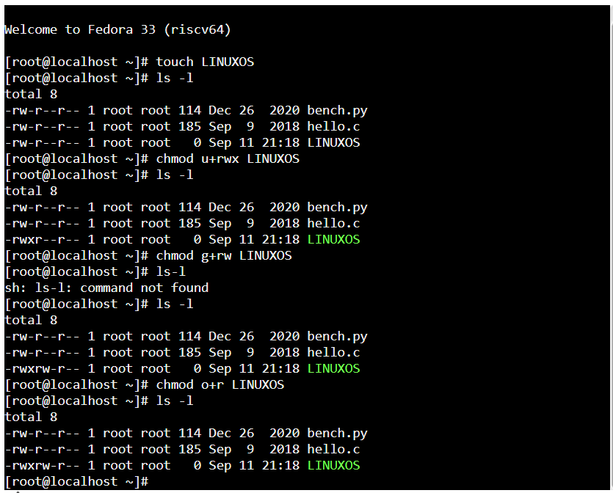

**Using Numerical Method:**

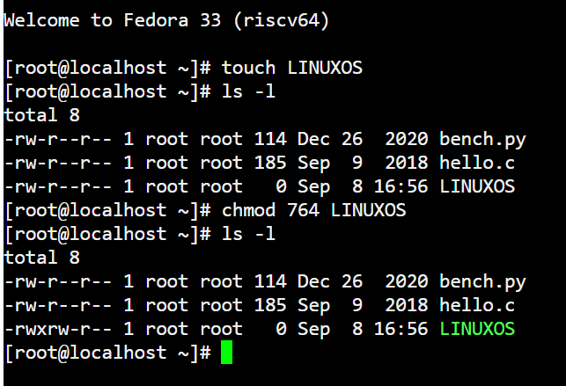

**Q2.** Create a directory called lab4 and create three files say quiz, report and cprogram inside the directory. Now try to set the following rights;

-rw-r- - r- - quiz

-rw-rw - r- - report

-rwx rwx x cprogram

(02 Marks)

**Note:** Include screenshots, where required to illustrate your explanation.

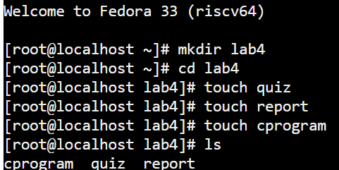

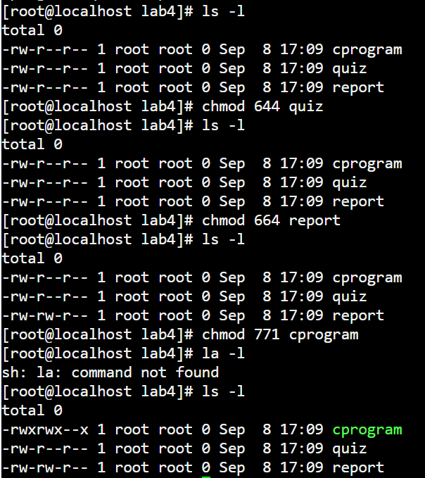

**Q3.** You are managing a project where you need to organize and summarize information for a class assignment. On your Linux system, you have two directories named OSLAB and OSTheory. In the OSLAB directory, your task is to create three text files: overview.txt with the text "Overview of Operating Systems," details.txt with the text "Detailed study of key OS concepts," and applications.txt with the text "Applications and examples of OS concepts." Once these files are created and populated, you need to combine their contents into a single file named Combinedtext. Now display the data in a Combinedtext.

**Note:** Include screenshots, where required to illustrate your explanation. (02 Marks)

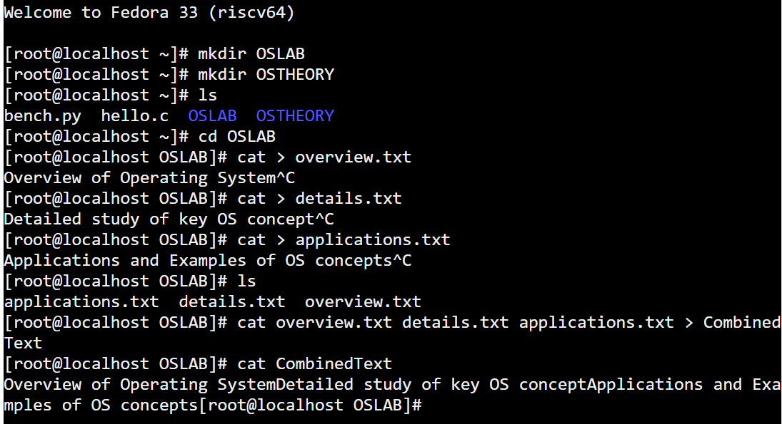

**Q4:** Directory A contains at least two files named "FinalTerm" and "MidTerm". Directory B contains at least two files named "OSTheory" and "OSLAB".

Your task involves the following steps:

Move the "MidTerm" file from the existing Directory to the Directory where the OSLAB file exists and Rename it with TASK.

**Note:** Include screenshots, where required to illustrate your explanation. (02 Marks)

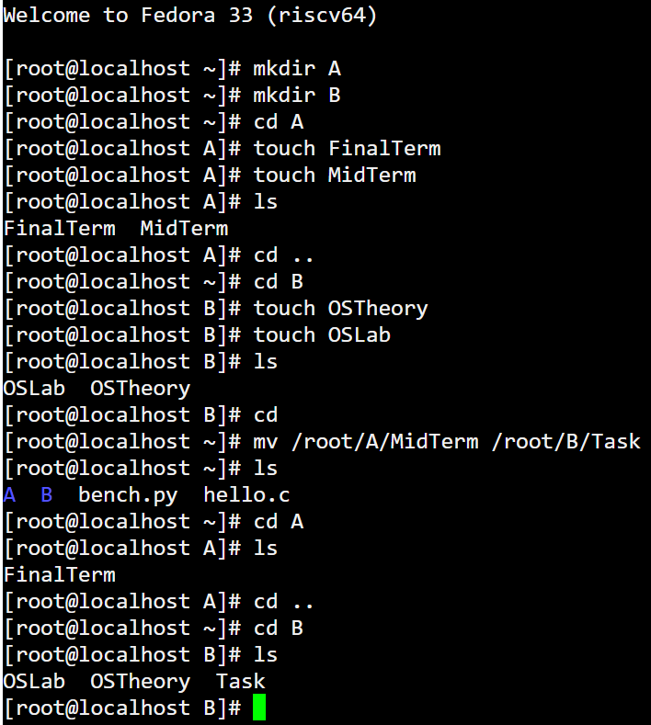

**Q5:** As part of your coursework, you have been assigned a project to develop a simple application on a Linux system. Your task is to write a C++ program that draws a circle on the screen. Describe the steps you would follow to complete this task, including the setup of the necessary library, writing the C++ code, compiling the program, and running it to display the circle. What commands and procedures would you use to accomplish this?

**Note:** Include screenshots, where required to illustrate your explanation. (02 Marks)

